Turing Project

Goal of Turing Project:
Through the Hans Niemann Scandal and other cheating events, I have realized a paradox: it is impossible to differ engine played moves from high level chess players played moves. Even if I used an engine, it makes it very hard for chess.com, the largest chess website, to decide if I am using an engine or not.
Nowadays, offline, officials must rely on metal detectors to prevent any cheating devices. Online, the only method of detecting is through accuracy checks, time elapsed (many cheaters will take 10 seconds to move every move), and abnormal rating rising.
From Go world champion Ke Jie words, I realized that there might be a new fundamental difference that targeted the basis of engine moves, one that can differ human chess players from engines not due to accuracy but due to their own style.
I call this difference the risk of a move.

Risk of move:
The risk of a move tries to capture a player’s mind in transposing positions. It depicts of a player’s willingness to take more risk to transpose into complex positions and playing for a win. It is calculated through the difference in Stockfish’s evaluation of the position till a specific depth based on the player’s strength. The risk of a move is not affected by the quality of move. A simple mistake will result in a simple tactic that is deemed as simple position.
$$r=\frac{\int_{0}^{d}{\left|\frac{d}{dx}\left(eval[b_{1}]\right)\right| }}{d∙log⁡(1+\frac{\int_{0}^{d}{\left|\frac{d}{dx}\left(eval[b_{0}]\right)\right| }}{d})}$$

Experiments with 12 games:
Explanation:
Game1: White maintained a slow but concise advantage through the Spanish Exchange Variation. Through trading down pieces and controlling important squares, Black maintained his advantage in a solid position. However, White did not risk pushing further, and made a draw with Black. Black played much wobbly, displaying some wrong risky decision making.

Game2: White continued his bad decision making, transposing toward complex positions that quickly made it very dangerous for White to play. With precise and simple sacrificing, Black quickly gained the advantage without pushing hard for a win. Knowing that his position is bad, White moves with hesitation, which only results in greater pressure from Black.

Game3: A simple draw for both sides to shake of the loss from last game. Both players stabilized themselves to prepare for the next game. Black got some small advantage from White’s commitment to push a little forward, but nothing huge happens. With the small advantage, Black then tries to utilize it, but quickly stops and make a draw.

Game4: White opened with a strong center at the cost of simplifying the position. In this silent maneuvering game, white exerted pressure on black silently, while black solidify the defenses. With a misplay from black, white took hold of the advantage and sacrificed. Solidly, the massive center crushed down into a winning attack.

Game 5: White opened with the Spanish opening and left Black with a bad bishop. Trying the open up lines, Black pushed back, but ultimately faltered at White’s defenses. With the good pieces, White rolled down Black with kingside pawns. There is nothing that Black can do to stop it or complexify the position. White won with great piece coordination to win the game with commitments.

Game 6: White opened up with the surprising London Defense (never seen in the world championships). Black, who does not really know how to deal with this type of playing, quickly created a plan that invokes complexity and transposition. However, the understanding of the position is incorrect, leading to a firm advantage of White. Later, White deployed a fantastic blow with piece coordination which the computer need to search down the lines.

Game 7: The surprise French Defense gave Black a advantage at first, but White retaliated back with moves that are not good but provide great pressure. Though Black made the correct decision in brilliant sacrificing moves, the position is ruined in terms of Black’s perspective. The pressure from White came down, resulting in time pressure that leads to 3 simple mistakes that gave away all of the advantage and lose the game.

Game 8: White at first brought out a secret weapon, aiming to complexify the position with opening files to attack. Under pressure, Black was forced to make risky moves, including bluffing out White with a sacrifice (it is not going to work under deep caclulation). The bluff worked. Despite White tried to exert some amount of pressure by maintaining the pressure, Black escalated the game quickly.
Game 9: The position begins with White’s Spanish opening, but this time White only commits little as there is no need to win one more game. Black opens up the position, leading to both sides attacking on different lanes. Under a point, Black tried to take White into a battle, firing back at White with pawn storms. Despite Black tried to sacrifice a piece to take a win, White rejected the sacrifice and led the game to a draw.

Game 10: Under Black’s preparation, White cannot find any way of taking the upper hand from Black. With careful preparation, the risky moves are actually well calculated to lead to a draw. With the aggression at hand, White must carefully deal with it to remain better, but the momentum to win is lost.

Game 11: White maintained pressure on Black, forcing many trades to simplify the position onto a drawn position. Despite tries to complexify the position in this simplify position. Basically nothing happens hard in this game.

Game 12: White started on risking everything to launch an attack. However, White’s attack backfired, and Black solidly gained the forehand. Unable to push on the attack, White started poking around Black’s defenses. Black started to make risky moves, which are okay, but instead complexify the position. Under many missed wins and tactics, Black’s transposition into complex position backfired on himself. A final blunder from Black aimed to continue attack costs him the game.
Game 13: Through the Spanish Opening, White started to look for a win, advancing for moves that are strong and risky, opening up the position. However, the opening up of the position was better for Black. Quickly, Black is on the initiave and look for a win.
Game 14: The last game involving in both sides trying to look for a win, and push the risk too far, leading to constantly turning up and back positions that ultimately ended in a draw.

Graph
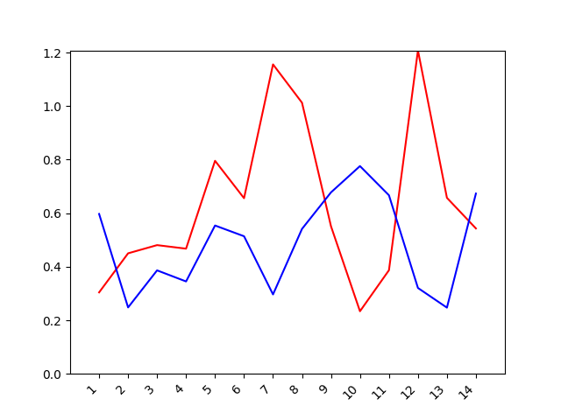

Chess anaylsis tool

Process:
Inspiration:

1v
2v
Earthquake Project
3v

